**SIDEBAR - MODULES OVERVIEW**

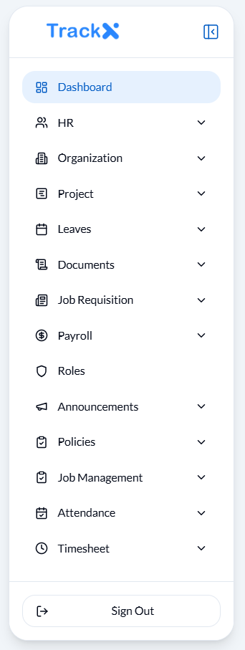

This sidebar provides easy navigation to all major modules of the system:

**Dashboard:** Overview of system stats and activities.

**HR:** Manage employee records, statuses, designations, departments, and asset assignments.

**Organization:** View and manage the company hierarchy structure.

**Project:** View and track project details.

**Leaves:** Submit and manage leave applications and leave requests.

**Documents:** Upload, categorize, and manage company documents.

**Job Requisition:** Create and manage job requisition forms and listings.

**Payroll:** Calculate payroll and access the list of generated pay slips.

**Roles:** Manage user roles and responsibilities across the system.

**Announcements:** Create and manage organization-wide announcements.

**Policies:** View leave policies, holidays, and shift schedules.

**Job Management:** Handle job postings and related details.

**Attendance:** Track and view employee attendance records.

**Timesheet:** Monitor and manage employee timesheets.

**Settings:** Access and update general system settings.

**Sign Out:** Logout from the system.

**HR 🡪 ADD EMPLOYEE**

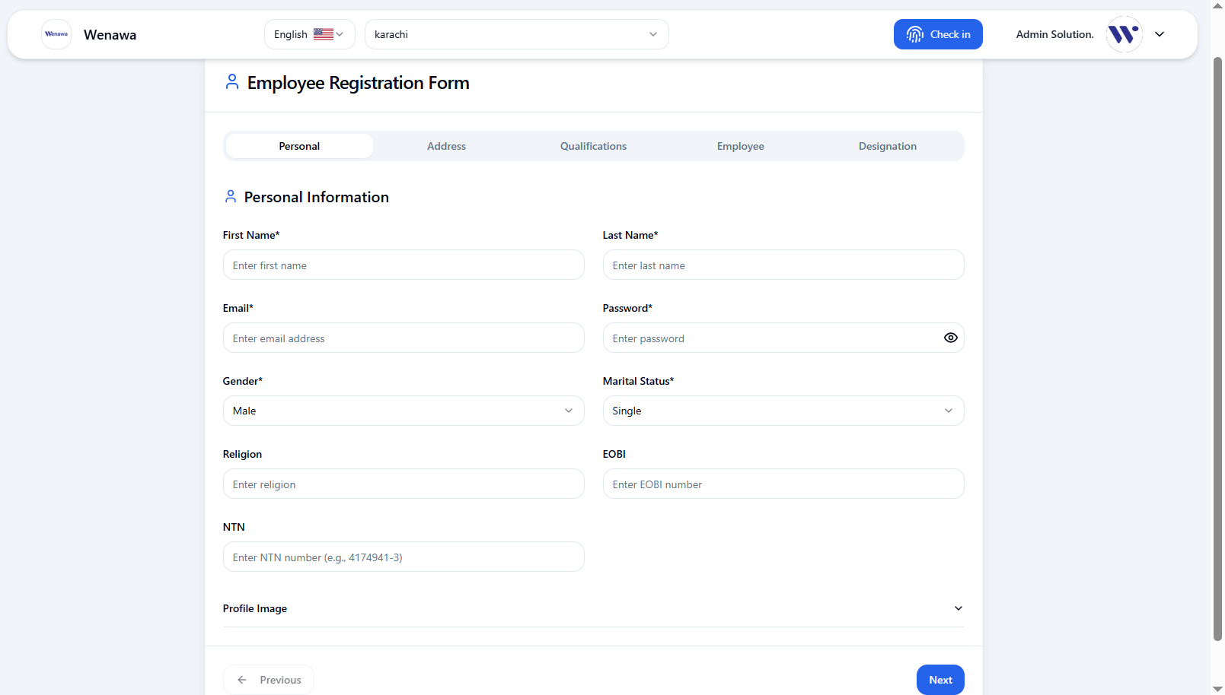

**ADD EMPLOYEE FUNCTIONALITIES**

1. Register a new employee into the system with detailed personal information.
2. Enter the employee's full name, email address, password, select gender and marital status from predefined options, employee’s religion, EOBI number, NTN and Upload a profile picture of the employee.

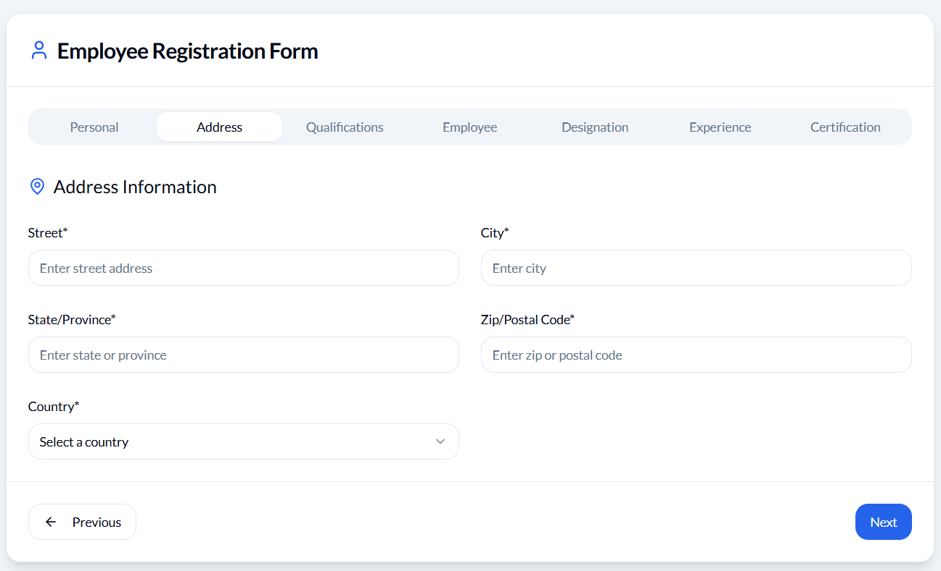

1. Enter the full street address, city, state or province, postal or zip code and select the country from the dropdown.

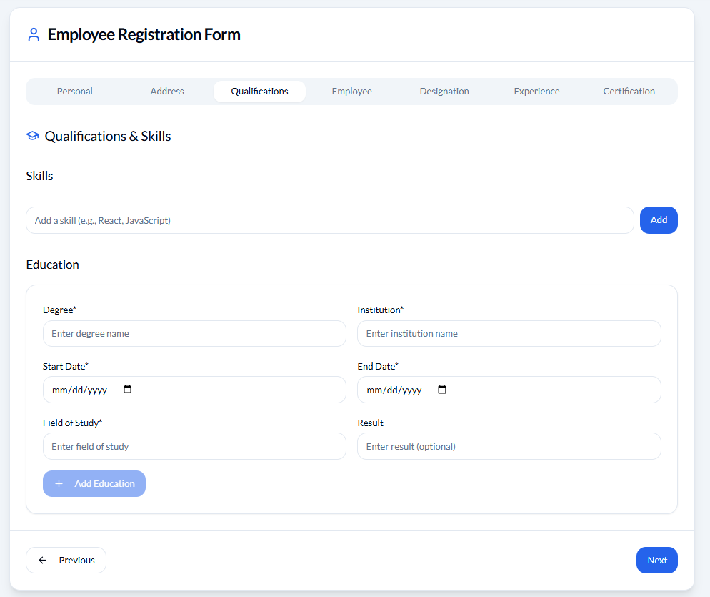

1. Add skills, education include fields (degree, institution, start and end date, field of study, result)

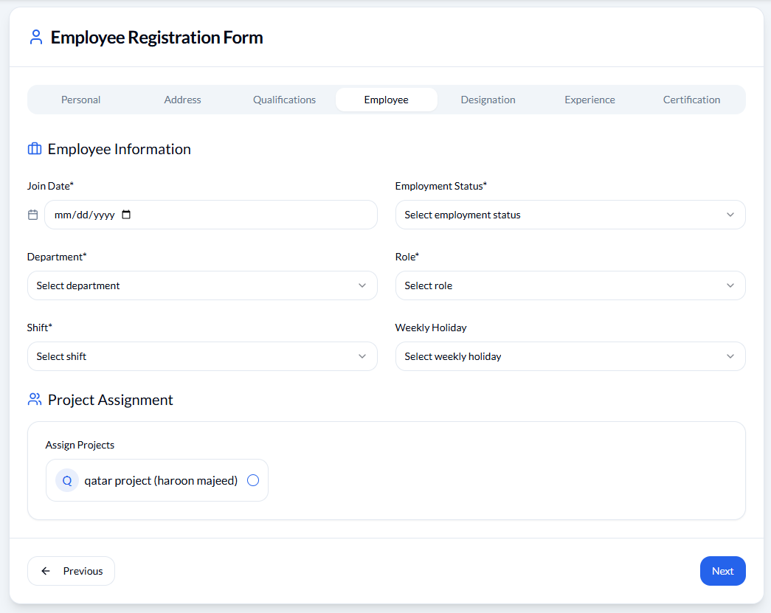

1. The official date the employee starts working, select employment status, department, role, shift, weekly holidays, from dropdown. Assign the employee to specific projects.

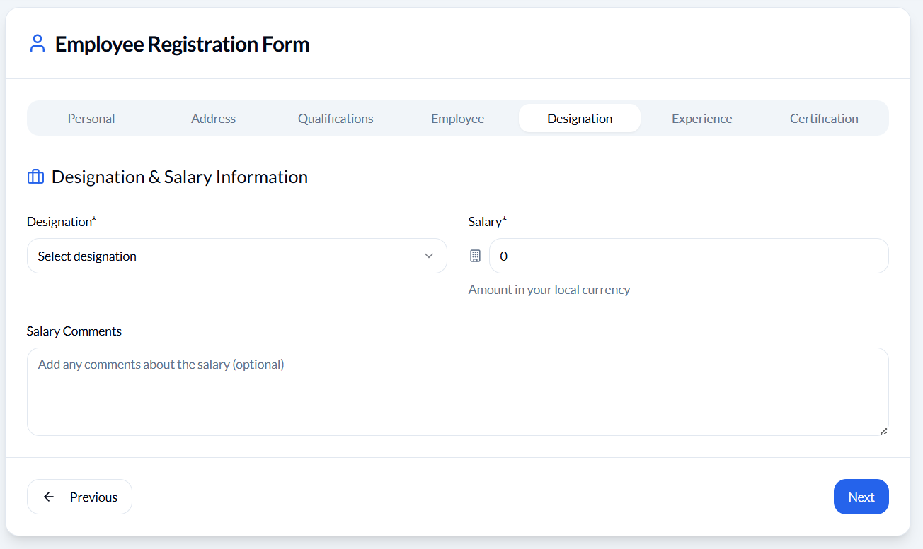

1. The official job title assigned to the employee, employee’s monthly salary amount, Additional notes or remarks related to the salary.

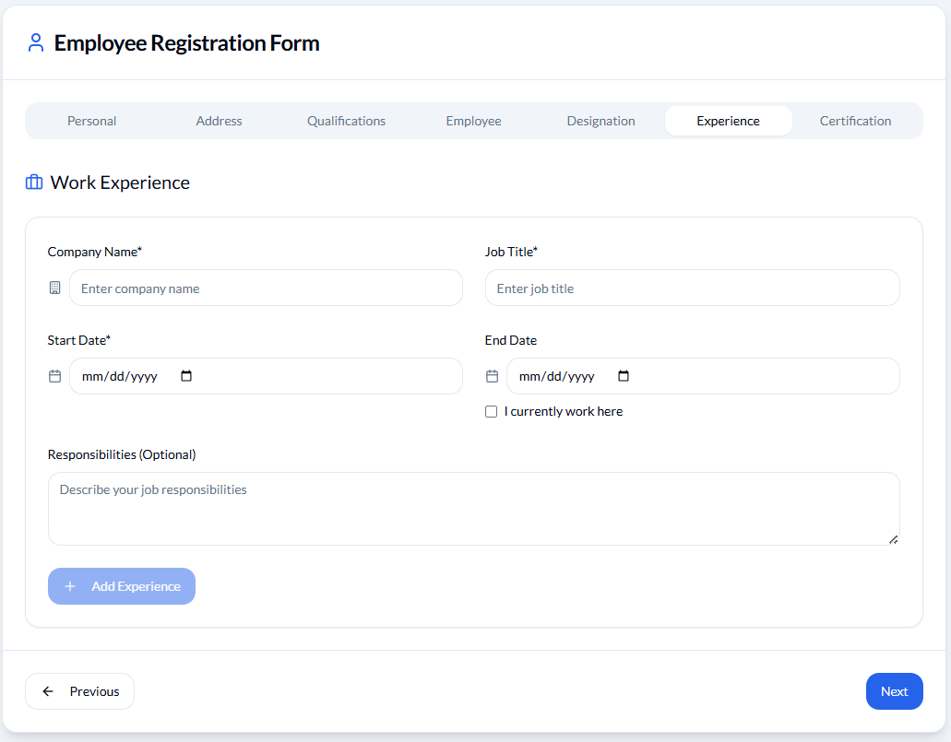

1. Write name of the organization where the employee previously worked, job title, duration of employment. A brief description of duties and responsibilities handled in that job.

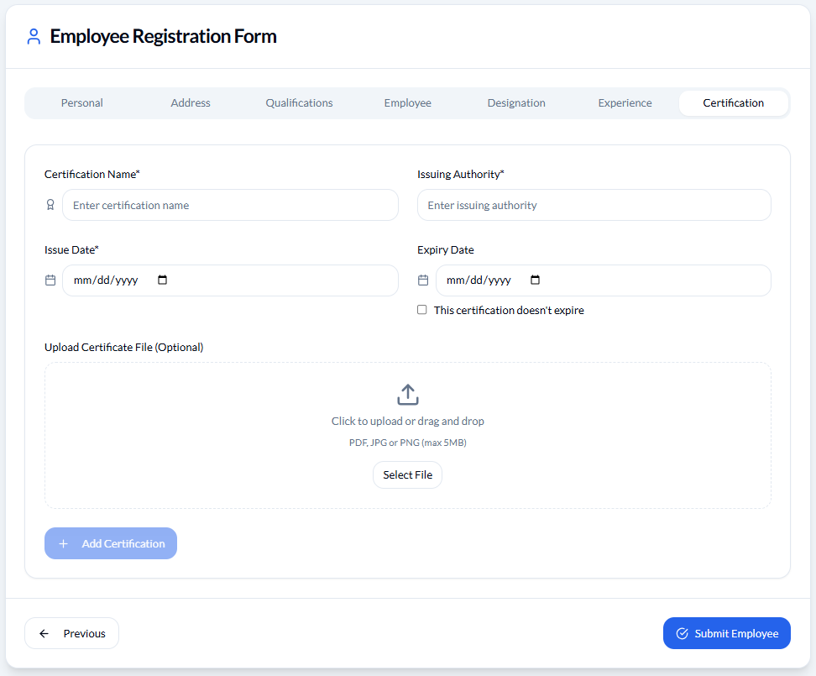

1. Enter certification name, issuing authority, issue date, expiry date, and Allows uploading a digital copy (PDF/Image).

**HR 🡪 VIEW EMPLOYEE**

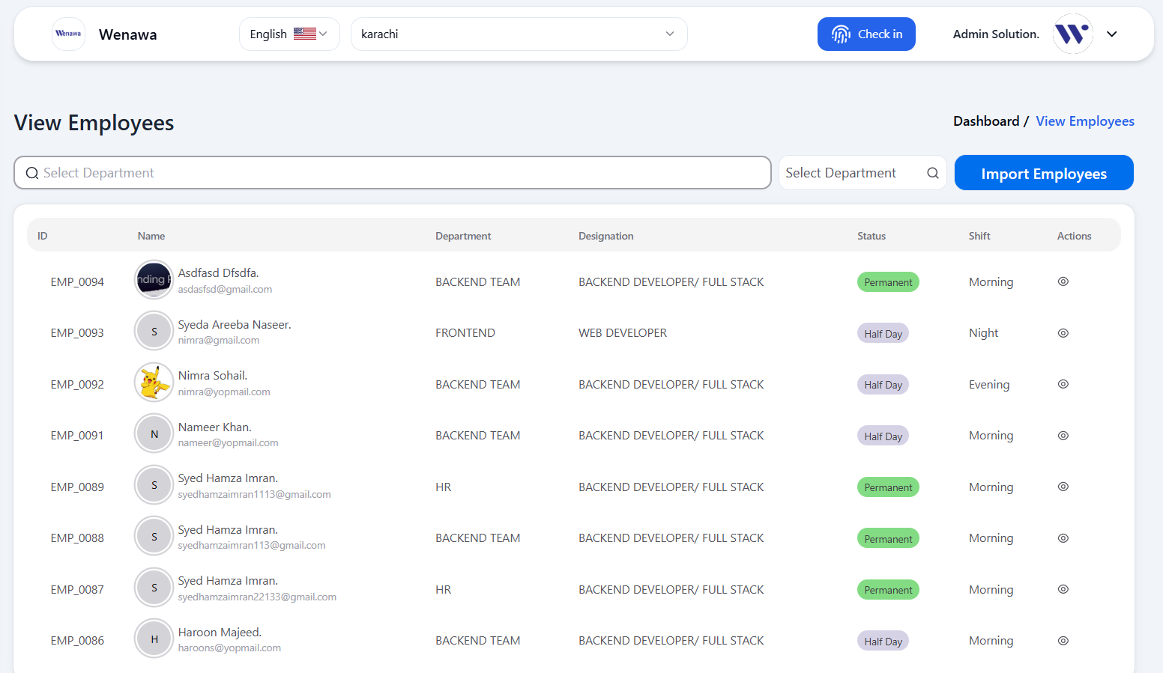

**VIEW EMPLOYEE FUNCTIONALITIES**

1. Upload employee data using a structured file format (e.g., CSV/Excel).
2. Filter employees based on their assigned departments.
3. Quickly find specific employees by entering their employee ID or name in the search bar.
4. View full employee profiles including personal, professional, and salary details.

**MY PROFILE**

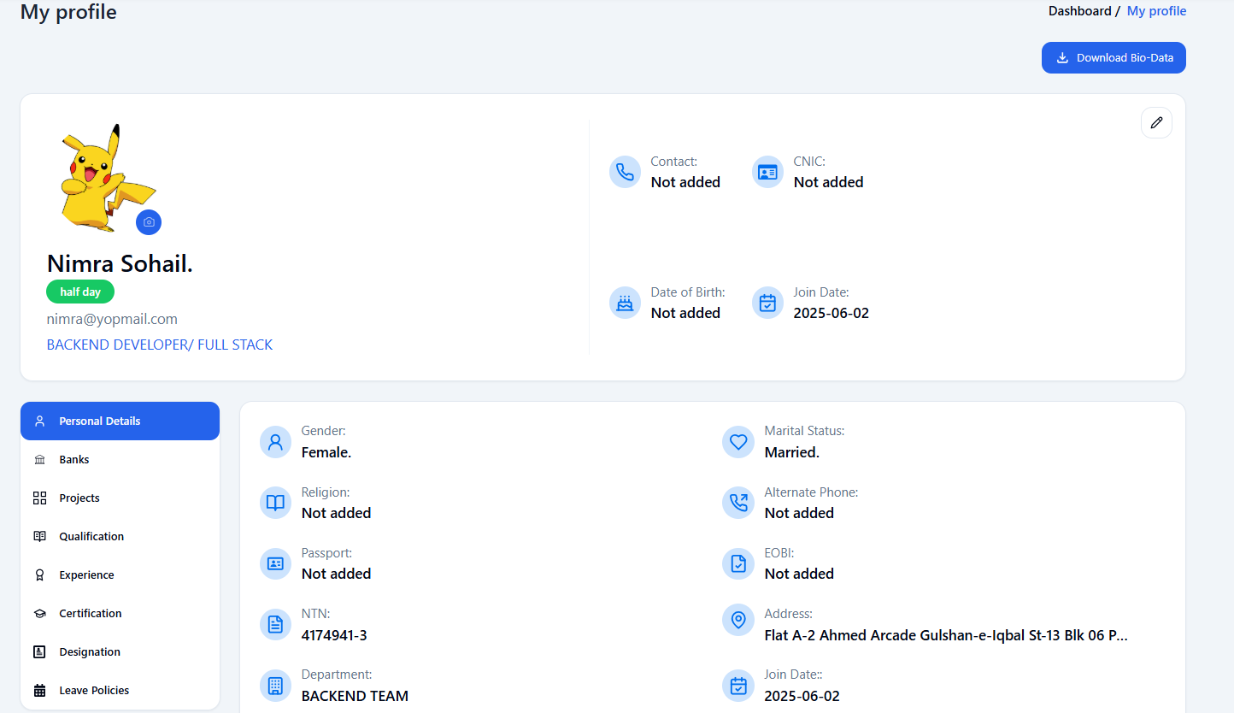

**MY PROFILE FUNCTIONALITIES**

1. View and edit personal information such as name, contact, and identification details.
2. Add or update bank information for payroll processing.
3. View a list of projects currently assigned to the employee.
4. Add, view, or update academic qualifications with institution details.
5. Maintain a record of past job roles, responsibilities, and durations.
6. Upload certifications along with issuing authority, issue and expiry dates.
7. Track designation changes and career progress over time.
8. Monitor remaining leave quota across various leave types.
9. Download a structured bio-data document for official use.
10. Upload or change the profile picture.

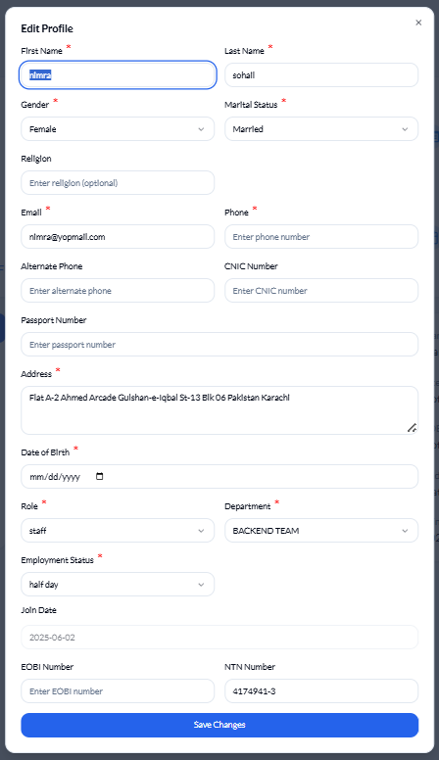

1. Access an editable form to update all profile-related fields.

**HR 🡪 EMPLOYMENT STATUS**

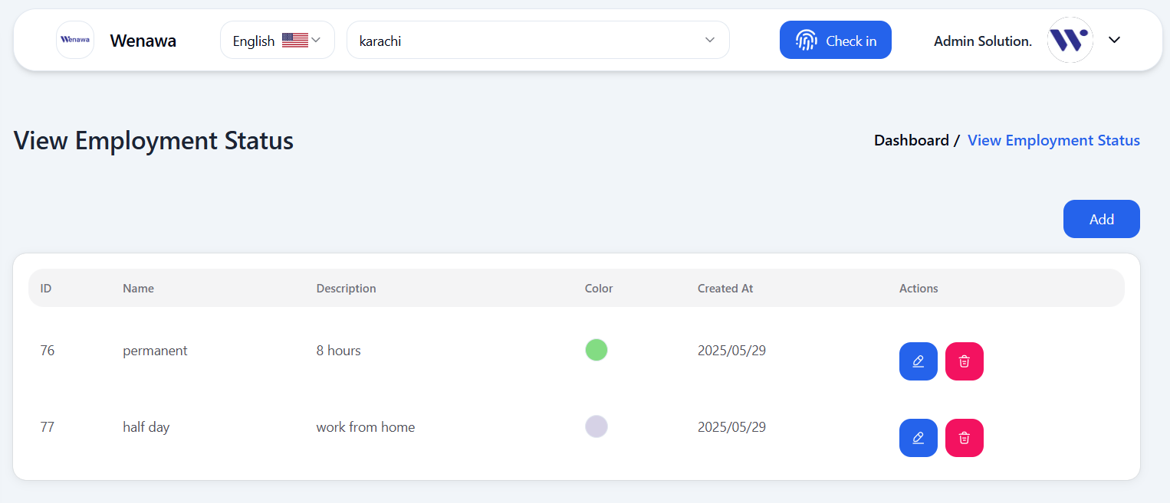

**EMPLOYEMENT STATUS FUNCTIONALITIES**

1. Create new employment status.
2. Edit existing employment status names or descriptions.
3. Delete employment status.

**HR 🡪 VIEW DESIGNATIONS**

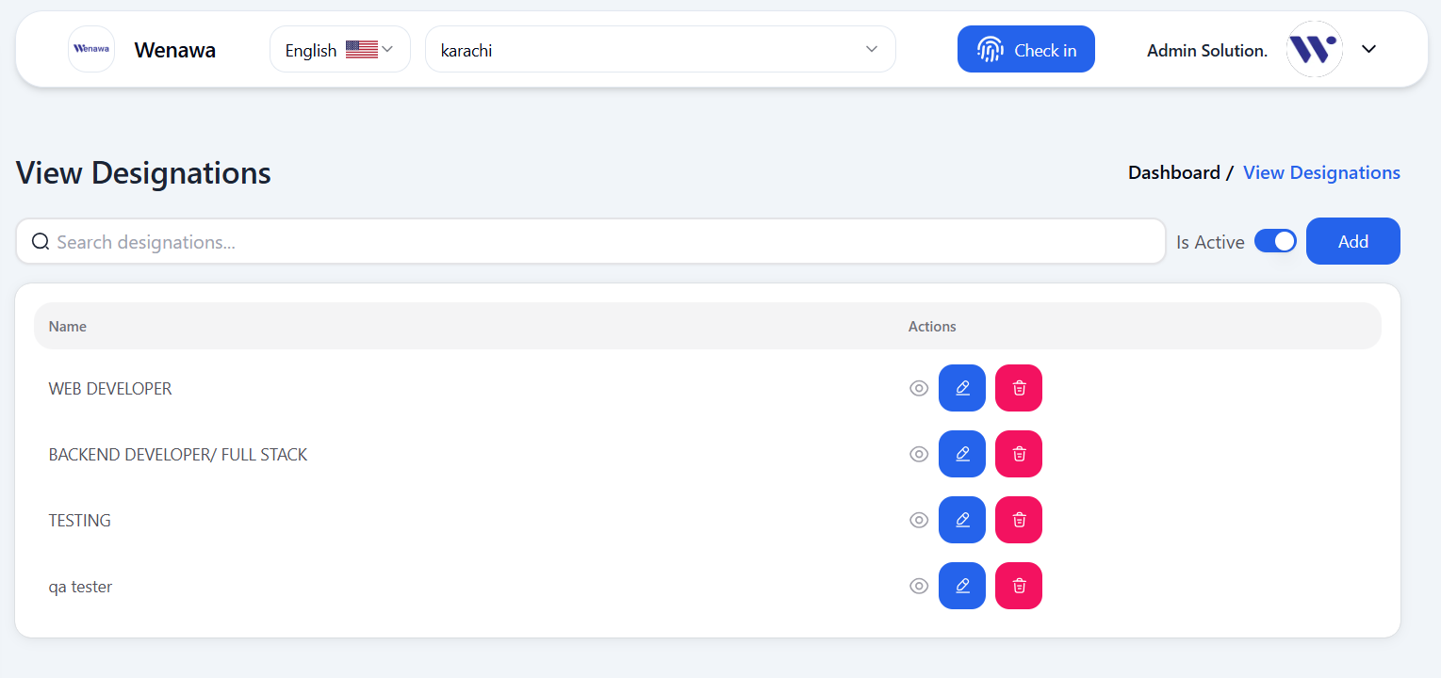

**VIEW DESIGNATION FUNCTIONALITIES**

1. Create a new job title or designation and optionally assign a reporting authority.
2. Designate a superior role or position that the new designation reports to.
3. View designation details.
4. Edit the name or reporting structure of an existing designation.
5. Delete designations that are no longer needed.
6. Quickly search a specific designation using the search bar by their name.
7. Enable or disable a designation's active status through the toggle switch.

**HR 🡪 VIEW DEPARTMENTS**

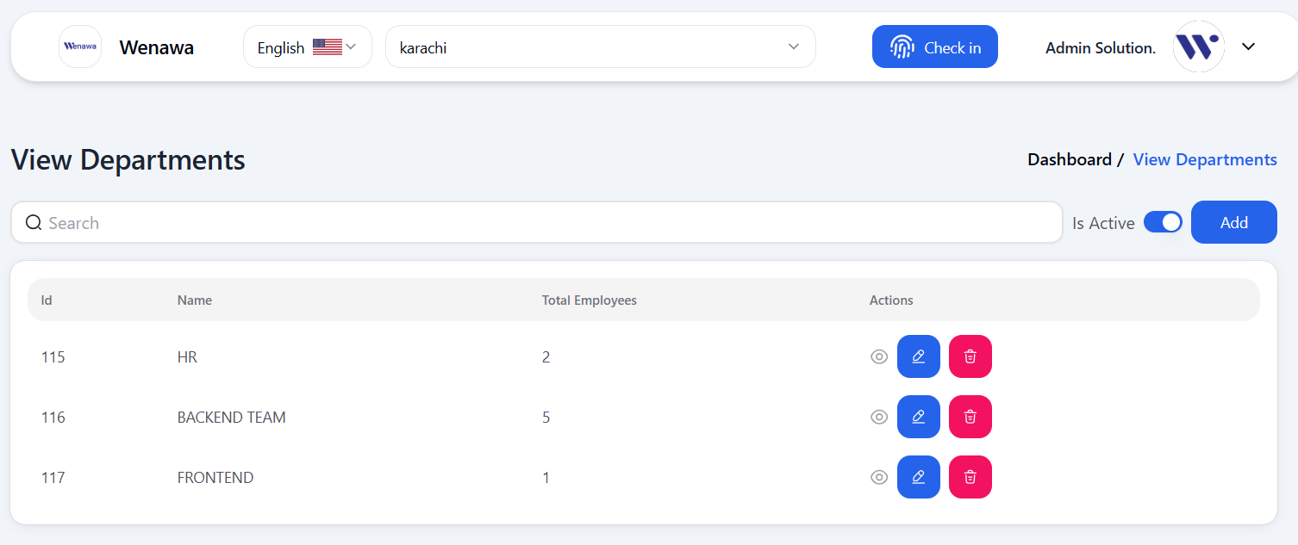

**VIEW DEPARTMENTS FUNCTIONALITIES**

1. Create new departments as needed for organizing employees.
2. Quickly find departments by typing in the search bar by their name.
3. Display a list of all departments with employee counts.
4. Update the department's name or other relevant details.
5. Delete departments that are no longer required.
6. Activate or deactivate departments show using the toggle button.
7. View department details.

**HR 🡪 ASSETS**

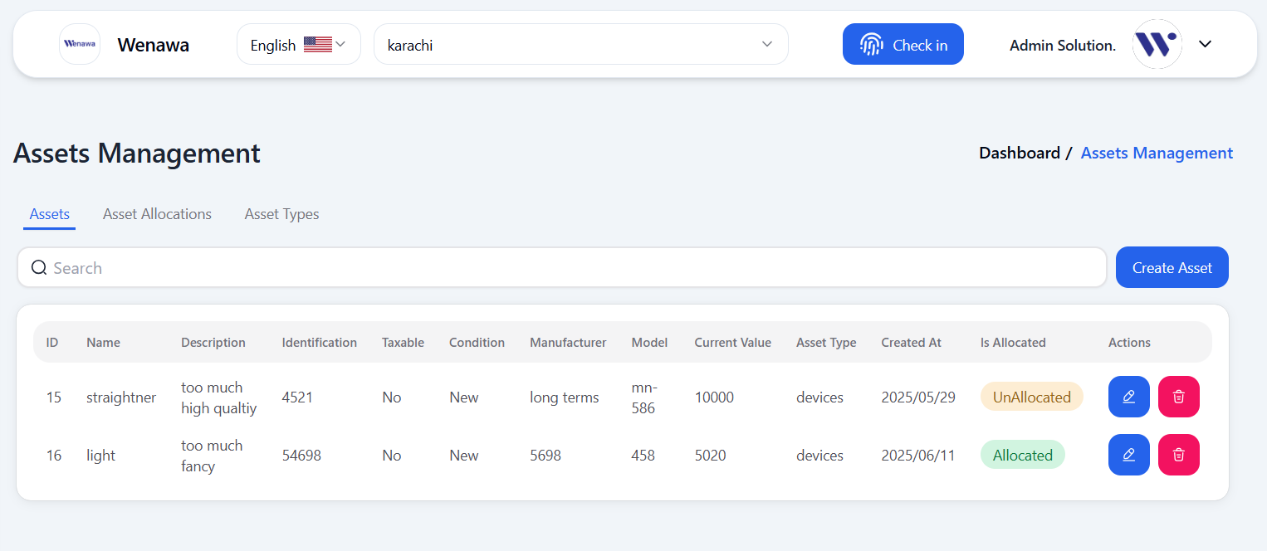

**VIEW ASSETS FUNCTIONALITIES**

1. Search assets using any column names shown in the asset table.
2. Add new assets by filling in relevant details such as name, asset type, ID, identification, etc.
3. Update existing asset details as needed.
4. Delete assets that are outdated or no longer in use.

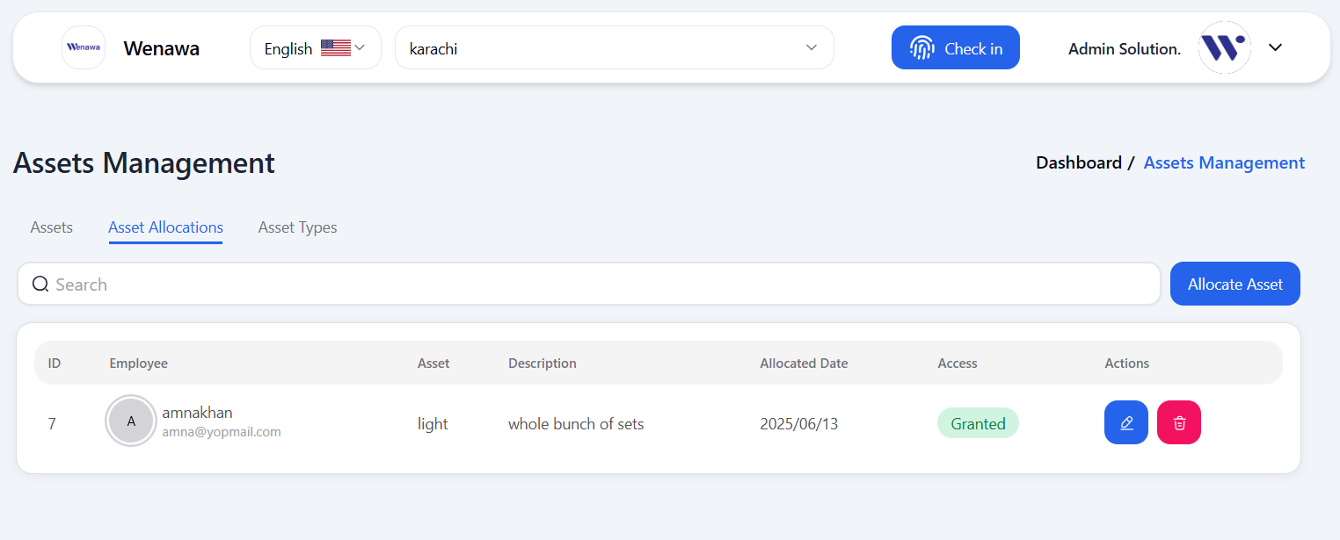

1. Assign assets to employees by filling in required details (employee, asset, date, etc.).
2. Find specific asset allocations using search functionality.
3. Edit or Delete any allocation as needed.
4. Once granted, the asset is officially assigned to the employee.
5. Once granted, the asset is officially assigned to the employee.

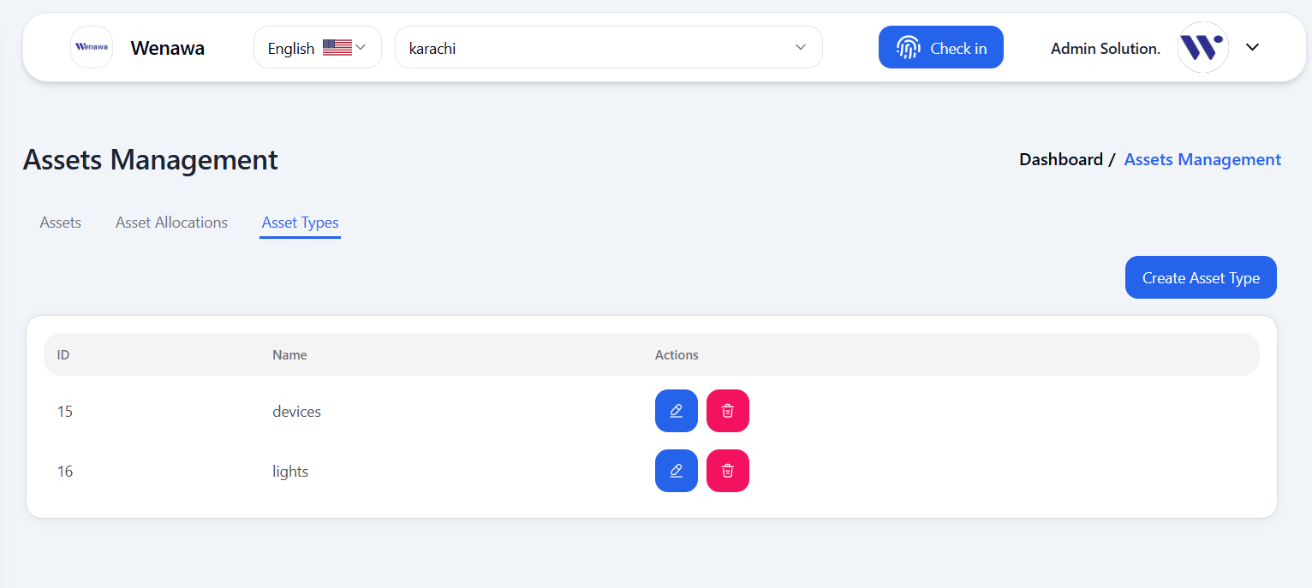

1. In Asset Type, you can create, edit, and delete.

**ORGANIZATON HIERARCHY**

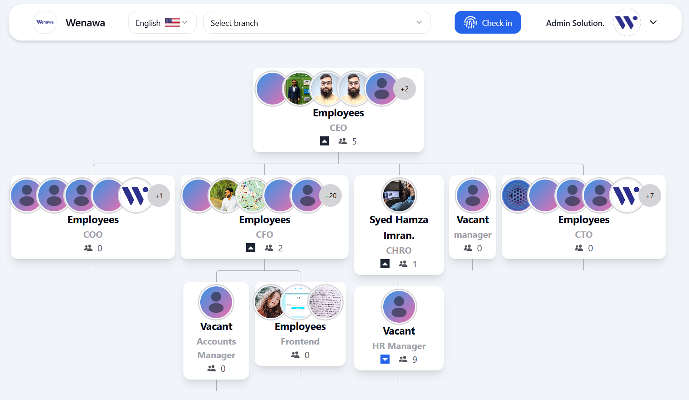

**ORGANIZATION HIERARCHY FUNCTIONALITIES**

1. Visual representation of the organization’s reporting structure.

**PROJECT**

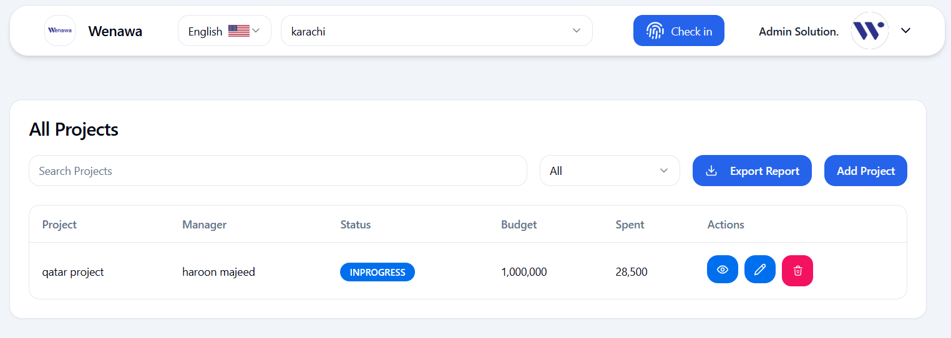

**PROJECT FUNCTIONALITIES**

1. Create a new project by filling in all required fields such as title, description, start and end date, priority, and status.
2. While creating a project, assign relevant employees to the project.
3. Search for a specific project by project name using the search bar.
4. Use filters to view projects based on their status: All, In Progress, Pending, On Hold, or Completed.
5. Export the list of projects in a downloadable format for reporting or backup.
6. View detailed project information including assigned team members and timeline.
7. Edit project details like dates, team members, or status.
8. Delete a project from the system if no longer needed.

**LEAVES 🡪 MY LEAVES**

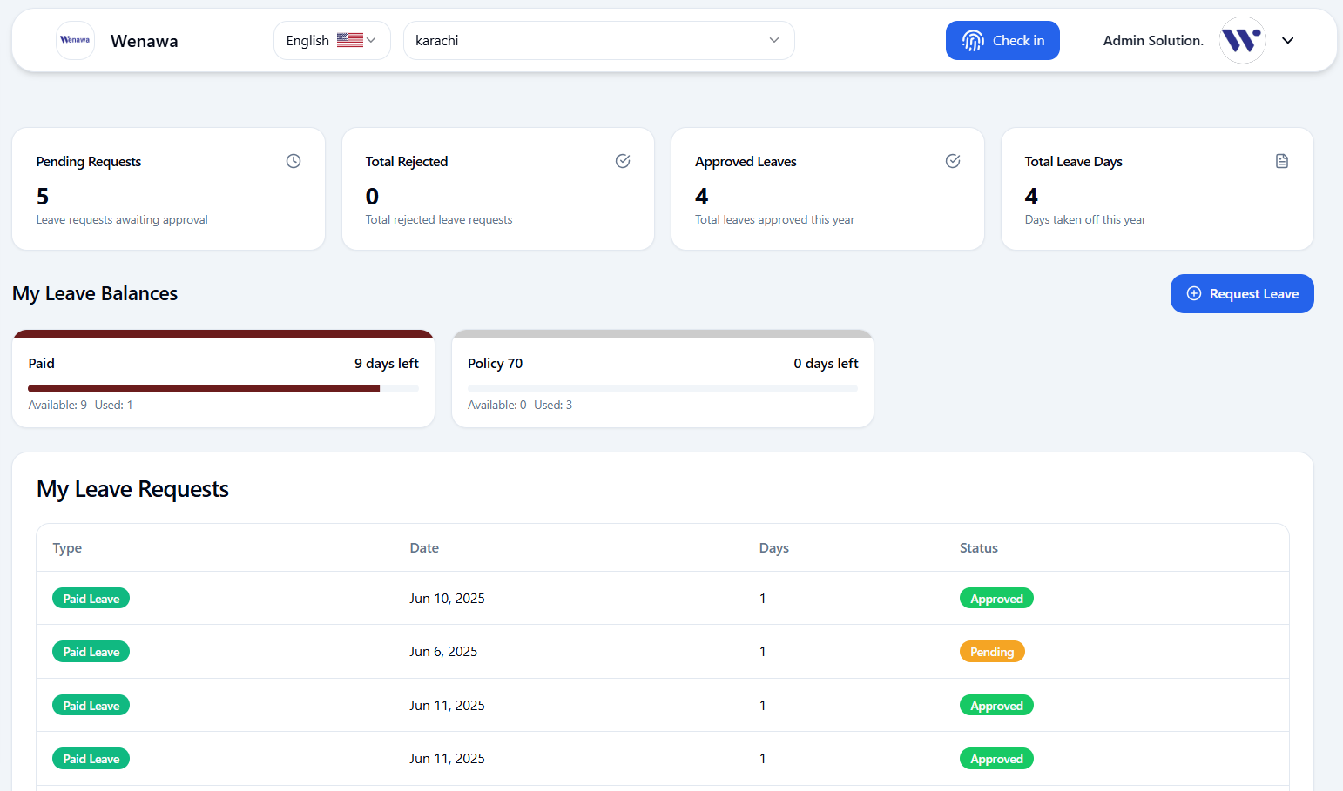

**MY LEAVES FUNCTIONALITIES**

1. View real-time stats including pending requests, total rejected, approved leaves, and total leave days.
2. Check remaining paid and unpaid leave days.
3. Submit a new leave request by selecting leave type, duration, and providing necessary details.
4. View a detailed list of all submitted leave requests with columns for leave type, dates, number of days, and current status.

**LEAVES 🡪 LEAVE REQUESTS**

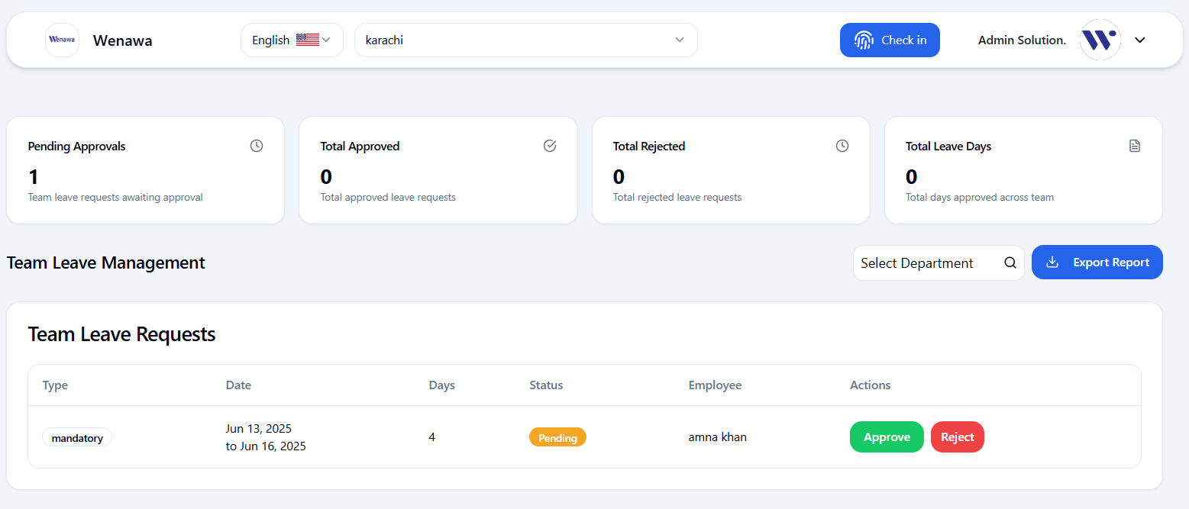

**LEAVE REQUEST FUNCTIONALITIES**

1. Export complete team leave data for reporting.
2. Select a specific department to view leave requests for that team only.
3. Search leave requests by employee name or related details.
4. Displays each employee’s leave details including type, date, days, status, and available actions.
5. Admin can approve or reject leave requests after reviewing each.
6. Shows summarized all employee leave statistics such as pending approvals, total approved, total rejected, and total leave days.
7. Only admins have visibility and control over the team leave request section.

**LEAVES 🡪 LEAVE TYPES**

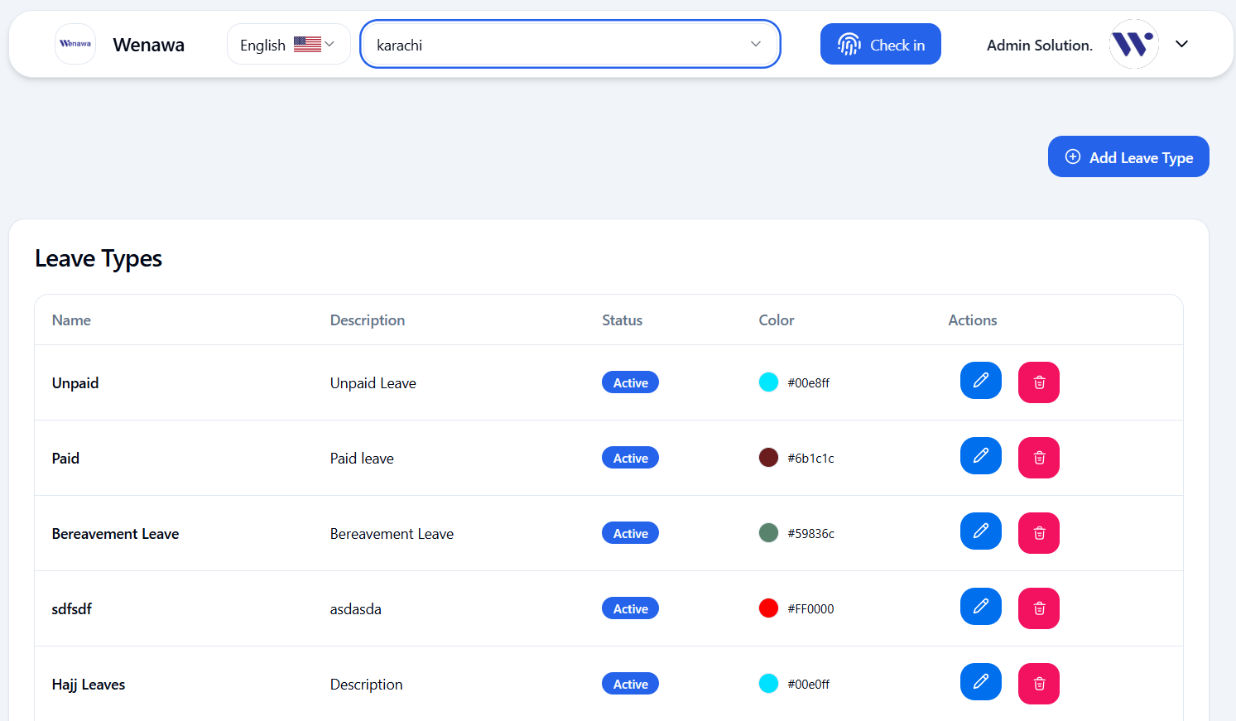

**LEAVE TYPES FUNCTIONALITIES**

1. Create new leave types by specifying name, description, color, and status.
2. Modify or remove existing leave types as needed.
3. Displays all leave types with columns for name, description, status (active/inactive), color, and action buttons for edit/delete.